**Program 2**

|  |
| --- |
| Importjava.io.*; |
|  | import java.util.*; |
|  | class Account |
|  | { |
|  | double balance; |
|  | Account() |
|  | { |
|  | balance = 0; |
|  | } |
|  | Account(double sum) |
|  | { |
|  | balance = sum; |
|  | } |
|  | double add(double sum) |
|  | { |
|  | balance += sum; |
|  | return sum; |
|  | } |
|  | double withdraw(double sum) |
|  | { |
|  | if (sum > balance) { |
|  | balance -= 5; |
|  | return -5; |
|  | } |
|  | else { |
|  | this.balance -= sum; |
|  | return balance; // Notice: always >= 0 (never < 0) |
|  | } |
|  | } |
|  | double inquire() |
|  | { |
|  | return balance; |
|  | } |
|  | double interest (double rate) |
|  | { |
|  | return rate * balance; |
|  | } |
|  | } |
|  | class bank1 |
|  | { |
|  | public static void main(String args[]) |
|  | { |
|  | try |
|  | { |
|  | Scanner s=new Scanner(System.in); |
|  |  |
|  | System.out.println("Enter account holder name:"); |
|  | String s1=s.next(); |
|  | System.out.println("Enter account type:"); |
|  | String s2=s.next(); |
|  | int b=0; |
|  | System.out.println("Enter the initial value"); |
|  |  |
|  | b=s.nextInt(); |
|  | Account A; |
|  | if (b==0){ |
|  | A = new Account(); |
|  | } |
|  | else{ |
|  | A = new Account(b); |
|  | } |
|  |  |
|  | System.out.println("Enter the amount to withdraw"); |
|  | b=s.nextInt(); |
|  |  |
|  | double d = A.withdraw(b); |
|  | System.out.println("Account holder name:"+s1); |
|  | System.out.println("Account type:"+s2); |
|  | if (d == -5) { |
|  | System.out.println("Penaly RS. -5 is charged since insufficient balance"); |
|  | System.out.println("Currrent balance" + A.inquire()); |
|  | } |
|  | else{ |
|  | System.out.println("Now balance after withdraw of"+ A.inquire() + "is" + d); |
|  | } |
|  | System.out.println("Interest for current balance" + A.inquire() + " is " + |
|  | A.interest(0.006)); |
|  | } |
|  | catch(Exception e) |
|  | { |
|  | System.out.println("Due to character exception"); |
|  | } |
|  | } |
|  | } |

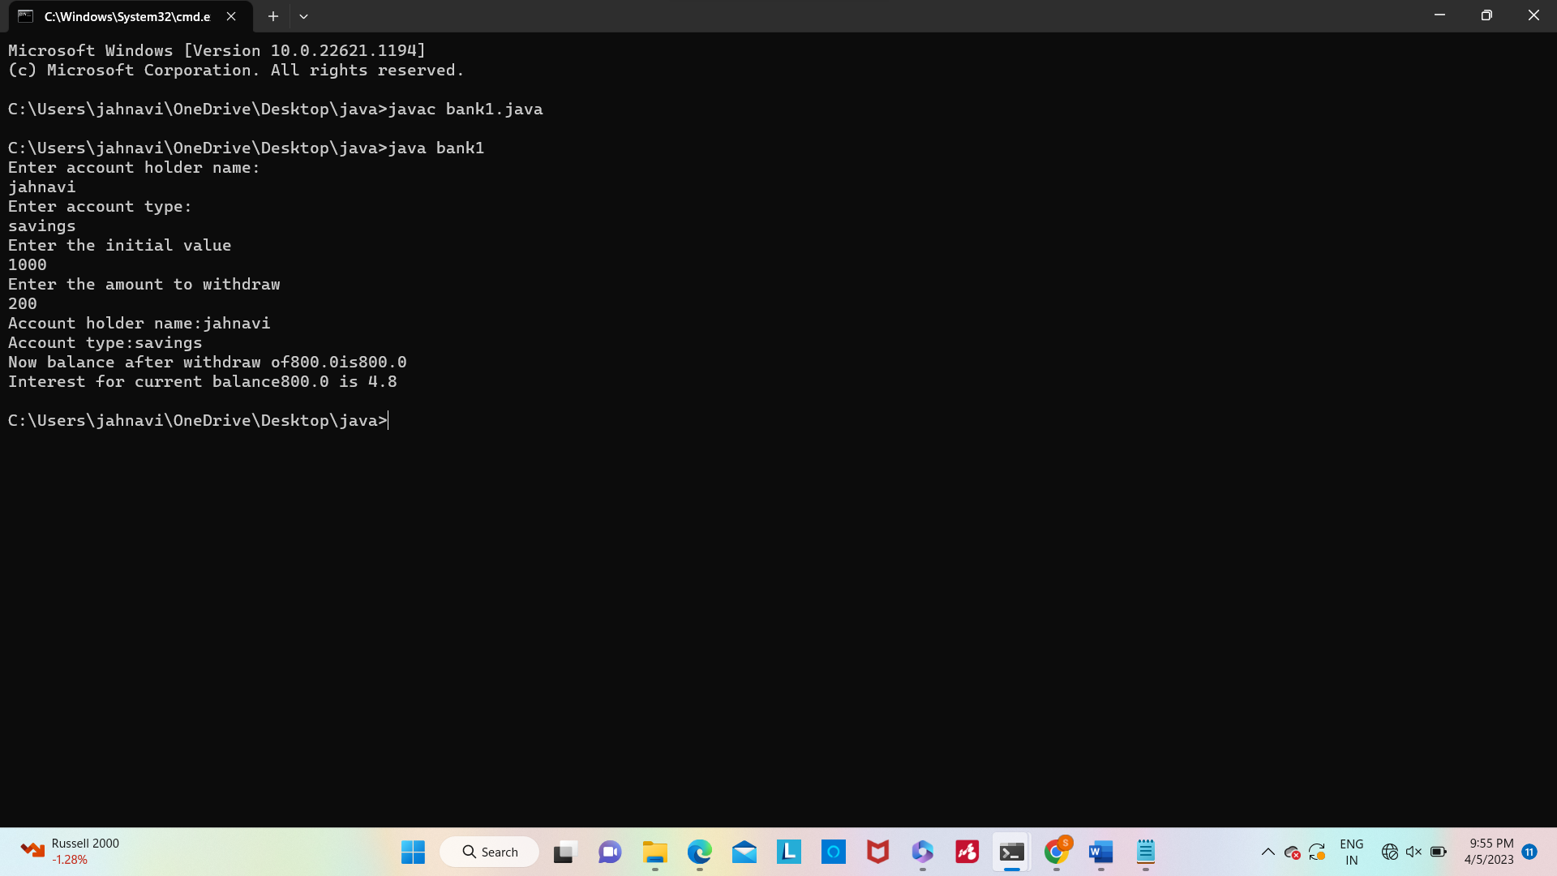

**Program 3**

public class ImplementStrStr {

public int strStr(String haystack, String needle) {

// Base condition

if (haystack == null || needle == null) {

return -1;

}

// Special case

if (haystack.equals(needle)) {

return 0;

}

// length of the needle

int needleLength = needle.length();

// Loop through the haystack and slide the window

for (int i = 0; i < haystack.length() - needleLength + 1; i++) {

// Check if the substring equals to the needle

if (haystack.substring(i, i + needleLength).equals(needle)) {

return i;

}

}

return -1;

}

}

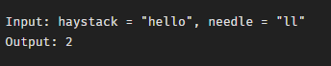

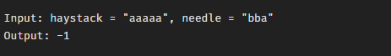

**Program 4**

import java.io.*;

import java.util.*;

public class lastw {

public static void main(String[] args){

int len = 0;

String x;

Scanner sc=new Scanner(System.in);

System.out.println("Enter the string :");

x=sc.nextLine();

String a= x.trim();

for (int i = 0; i < x.length(); i++) {

if (x.charAt(i) == ' ')

len = 0;

else

len++;

}

System.out.println("The length of last word is "

+ len);

}

}

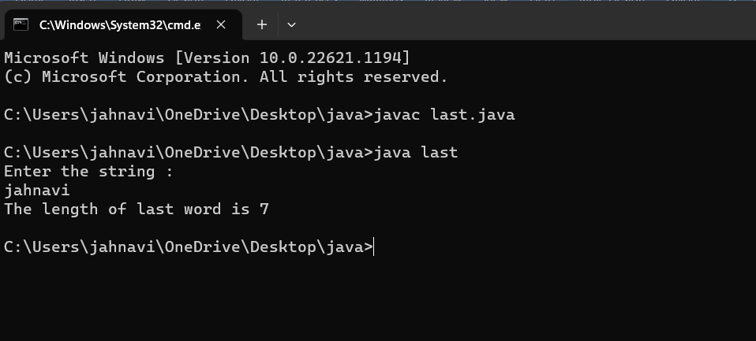

**Program 5**

import java.io.*;

import java.util.*;

class factor

{

public static void main(String args[])

{

try

{

Scanner sc=new Scanner(System.in);

int count=0,n,i;

System.out.println("Enter the number:");

n=sc.nextInt();

if(n<=0)

{

System.out.println("Enter valid number");

}

else

{

for(i=1;i<=n;i++)

{

if(n%i==0)

{

count++;

}

}

System.out.println("The number of factors:"+count);

}

}

catch(Exception e)

{

System.out.println("Enter only numbers");

}

}

}

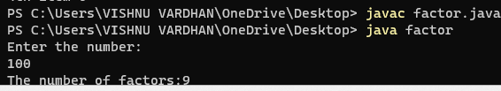

**Program 1**

**6)**

public class SubstringExample{

public static void main(String args[]){

String s1="saveetha";

System.out.println(s1.substring(2,4));

}}

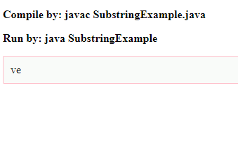

**7)**

public class StringTrimExample{

public static void main(String args[]){

String s1=" hello student ";

System.out.println(s1+"Welcome");

System.out.println(s1.trim()+"Welcome");

}}

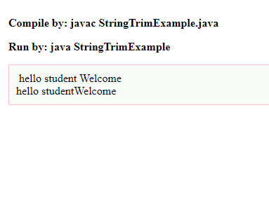

8)

public class LengthExample{

public static void main(String args[]){

String s1="Saveetha";

String s2="Java";

System.out.println("string length is: "+s1.length());

System.out.println("string length is: "+s2.length());

}}

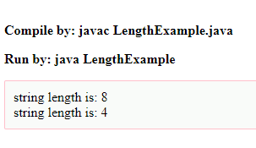

**9)**

String txt = "Hello World";

System.out.println(txt.toUpperCase());

System.out.println(txt.toLowerCase());

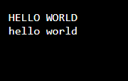

**10)**

class Teststringcomparison1{

public static void main(String args[]){

String s1="janu";

String s2="janu";

String s3=new String("janu");

String s4="janu";

System.out.println(s1.equals(s2));

System.out.println(s1.equals(s3));

System.out.println(s1.equals(s4));

}

}

